**REPRODUCTION**

Reproduction is the production of a new generation of individuals of the same species. It is one of the fundamental characteristics of living organisms. It involves the transmission of genetic material from one generation to the next ensuring that the species survives over long periods of time, even though individual members of the species die.

There are two basic types of reproduction:

**Asexual**

**Sexual**

**Asexual reproduction**

This is reproduction by a single organism with production of genetically identical offspring, the only genetic variation arising as a result of random mutations among the individuals. The forms of asexual reproduction include binary fission, budding, spore formation and vegetative propagation in plants.

**Vegetative propagation**

This is the most common form of asexual reproduction in plants. Vegetative propagation involves the production of new individual (young plant) from the vegetative part of an existing plant (usually the parent plant). Specialized organs of propagation often develop giving risen to new individual. Examples are bulbs, corm, rhizomes, stolon and tubers. Some of these organs store food and are means of surviving adverse conditions, such as cold periods or drought.

The food is used for growth when conditions become suitable. Plants possessing these structures can therefore survive from one year to the next. These structures are called perennating organs.

Vegetative propagation is the mode of reproduction in plants in which a vegetative part like the stem, root and leaves develop into new plant under favourable conditions. It can be classified into:

1. Natural vegetative propagation
2. Artificial vegetative propagation

Natural vegetative propagation occurs when an axillary bud grows into lateral shoot and develops its own adventitious roots. Plants structures that allow natural propagation include bulbs, rhizomes, stolons and tubers.

**Bulb**

Bulb is a modified shoot with very short stem and fleshy storage leaves with one or more buds and adventitious roots (i.e., they grow from the stem rather than

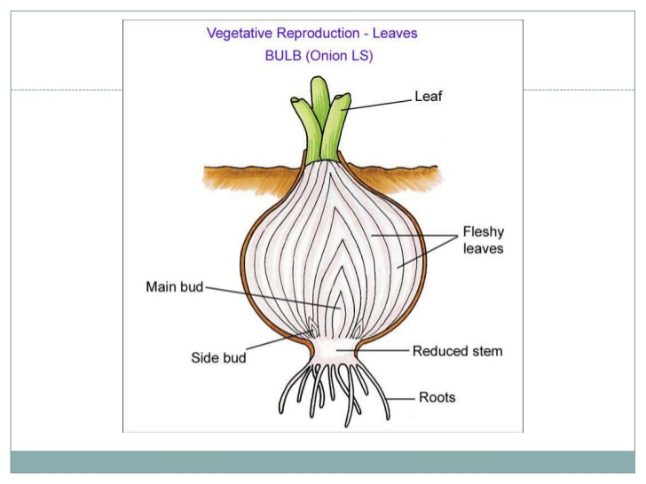

from a main “tap” root. e.g Onion (*Alium*). Each bud grows a shoot which produces a new bulb at the end of the growing season.

**Corm:-** A corm consists of a swollen, vertical underground stem surrounded by protective scale leaves with adventitious roots. There are no fleshy leaves unlike bulbs;

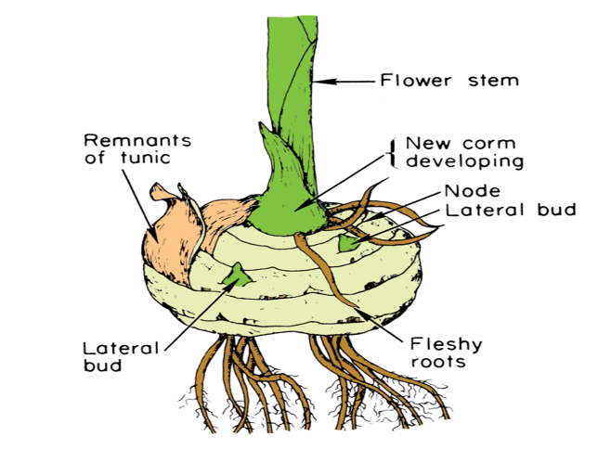

but the corm contains one or more buds which may result in vegetative propagation.

**Rhizome:-** A horizontally growing underground stem with scale-like leaves (small, thin, whitish, yellowish or brownish in colour). A rhizome bears scale-like leaves, buds and adventitious roots. e.g. Peppermint (from which menthol is gotten), ginger, tumeric.

**Stolon :-** A creeping, horizontally growing stem that grows along the surface of the ground; with adventitious roots growing from the nodes e.g., *Imperata cylindrica*

**Runner:-** A runner has several stems radiating from the parent plant. A runner bears scale leaves with axillary buds and the buds give rise to adventitious roots and new plants.

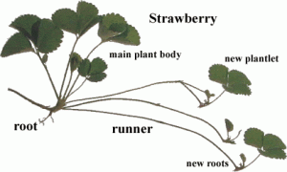

All runners elongate rapidly. The runners decay once the new plants are established e.g., sweet potato.

**Tuber:-** A tuber is an underground storage organ formed from stem or root, swollen with food and capable of perennation. It is of two types:

1. Stem tubers
2. Root tubers

**Stem tuber**: These are stem structures produced at the tips of thin rhizomes that become swollen from storing nutrients. The upper surface of the tuber produces

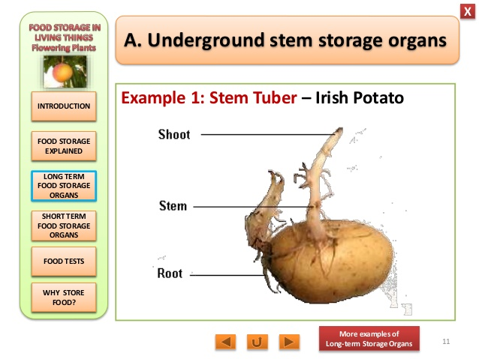

Irish potato, an example of a stem tuber

the new plant shoot system (stems and leaves), while the bottom surface produces the root system. Irish potatoes and yams are examples. Irish potato, an example of a stem tuber

**Root tubers:-** These are swollen tuberous adventitious roots e.g., Cassava.

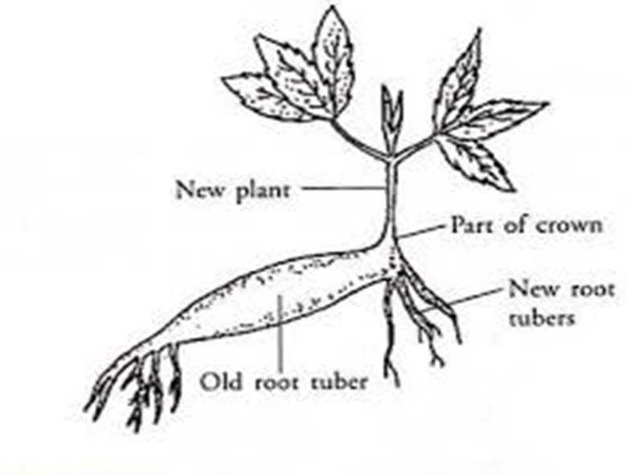

**Adventitious leaves:-** Leaves of *Bryophyllum* bear adventitious buds in the notches of the leaf margin.

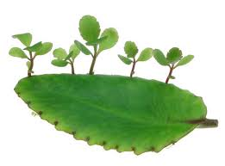

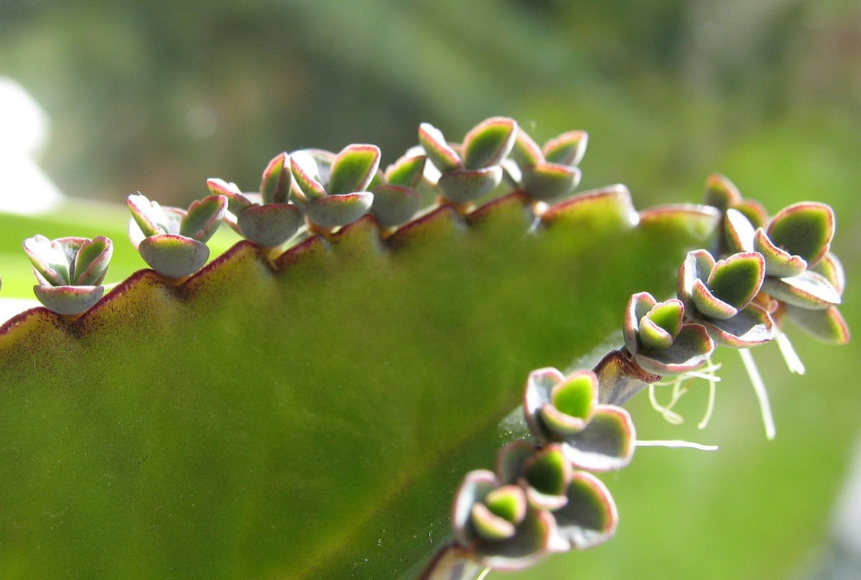

When leaf falls on the ground, the buds grow to form the independent plant.

**Sucker:-** Some plants reproduce from suckers, which sprout from the plant’s lateral roots. These suckers create new plants that emerge from the ground e.g. banana.Plants that reproduce from suckers can become problematic since they can spread throughout their niche.Example of a sucker e.g. banana

**Swollen tap roots:-** A tap root is a main root that develops from the radicle, the first root of the seedling.Tap roots are characteristic of dicotyledonous plants.

Tap roots may become swollen with food storing tissues as in carrot (*Daucus* sp). Swollen tap roots are characteristic of biennial plants.

**Artificial vegetative propagation:-** Artificial vegetative propagation is the deliberate production of new plants from parts of old plants by humans. This can be done by the following methods:Cutting**,** Budding**,** Layering and Grafting.

**Cutting:-** This is a simple procedure in which part of the plant is cut and planted. This gives rise to a new plant when planted e.g. stem cutting in cassava, sugar cane and root cutting in lemon.

**Grafting:-** This is the transfer of part of one plant, the scion, onto the lower part of another plant, the stock.The scion and stock are then engrafted together, these two plants eventually become one plant.The scion is chosen for its fruit and the stock for properties such as disease resistance and hardiness.

**Budding**:- This is a method in which a bud is used as the scion rather than a shoot. E.g., Citrus plant.

Layering:- This is used for plants that produce runners. The runners are pegged out around the parent plant, until they are rooted and are then cut to detach them from the parent plant.

**OTHER FORMS OF REPRODUCTION**

**Cloning**:- Cloning is the process of generating genetically identical copy of a cell or an organism either naturally or artificially. Cloning happens all the time in nature. For example, when a cell replicates itself asexually without any genetic alteration or recombination. Prokaryotic organisms lacking a cell nucleus such as bacteria; create genetically identical duplicates of themselves using binary fission or budding. In eukaryotes, such as humans with a cell nucleus, all the cells that undergo mitosis, such as the skin cells and GIT are clones; the only exceptions are gametes (eggs and sperm), which undergo meiosis and genetic recombination. Identical twins are example of natural clones. Cloning is done artificially by transferring the DNA from an animal’s somatic cell into an egg cell that has had its nucleus and DNA removed. The egg develops into an embryo that contains the same genes as the cell donor. The n the embryo is implanted into an adult females uterus to grow.

**Agamospermy**: is the asexual production of seeds and embryos without fertilization/ meiosis.or by means of asexual seeds; seed formation without the fusion of gametes. Agamospermy can occur in non-flowering plants such as Cycads, fir, spruce etc.

**Tissue culture or micro-propagation:- Method 1**: micro-propagation is the propagation or cloning of plants by tissue culture. (“micro” refers to the small size of the material used, usually isolated cells or small pieces of tissue. The material is grown in special culture solutions, so the process is also known as tissue culture.

The culture solution contains nutrients and certain plant hormones such as auxins and cytokinins (cell division). Tissue culture is widely used for the apical propagation of desired varieties. Temperature, light intensity, light quality and humidity are all controlled by growing the cultures in special growth rooms or cabinets. All procedures must be sterile because bacteria and fungi can also grow in the culture. The plant tissues are surface sterilized in a dilute bleach solution and other materials are also sterilized before use. All apparatus must be handled under sterile conditions.

**Method 2**: Another method is to produce a callus from non-meristematic tissue.

A callus is an undifferentiated (unspecialized) mass of cells. Roots or shoots can be stimulated to grow from a callus or from non-meristematic tissue by adding auxins or cytokinins. The basic forms of sexual reproduction in animal kingdom are fission (binary and multiple), budding and fragmentation. Binary fission is common among bacteria and protozoa. In binary fission , the body of the unicellular parent divides by mitosis into equal parts, each of which grows into an individual similar to the parent. e.g *Amoeba proteus.* Binary fission may be lengthwise as in flagellate protozoa or transverse as in ciliate protozoa.In multiple fission, schizogony, the nucleus divides repeatedly before division of the cytoplasm producing many daughter cells simultaneously.Spore formation called sporogony is a form of multiple fission common among some parasitic protozoa e.g malarial parasites.

**Budding:-**  This is an unequal division of an organism.A new individual arises as an outgrowth (bud) from its parent, develops organs like those of the parent and then detaches itself. e.g., Yeast and hydra.

**Fragmentation:-** A multicellular animal breaks into two or more parts, with each fragment capable of becoming a complete individual. Many invertebrates can reproduce asexually by simply breaking into two parts and then regenerating the missing parts of the fragment.e.g *Planaria.*

**Sexual Reproduction:-** This is the production of individuals from gametes, that is, fusion of two haploid gametes to form a diploid zygote which develops into the new organism. The act of fusion is called fertilization.Meiosis is an essential feature of life cycle in which sexual reproduction occurs because it provides a mechanism for reducing the genetic material by half.This ensures that when gametes fuse, the diploid number of chromosomes is restored.

During meiosis, random segregation of chromosomes (independent assortment) and exchange of genetic material between homologous chromosomes (crossing over); results in new combination of genes being brought together in the gamete and this reshuffling increases genetic variation.

The combination of two sets of chromosomes (genetic recombination), one set from each parent in the zygote from the basis variation within species.

Species that have separate male and female individuals are described as unisexual capable of producing both male and female gametes within the same organism.

Examples of organisms that are hermaphrodite or bisexual include many protozoans, Paramecium, cnidarians such as Obelia, Platyhelminthes such as Taenia (tapeworm), oligochaetes, such as Lumbricus (earthworm), crustacean such as balanus (barnacles), molluscs such as Helix (garden snail), some fish, lizards, birds and most flowering plants are hermaphrodite. Nearly all vertebrates and many invertebrates have separate sexes and such a condition is called monoecious and the animals are called hermaphrodites.

**Abnormalities of Sexual Reproduction in unicellular organisms and plants.**

**Parthenogenesis**: This is the development of an embryo from an unfertilized egg or one in which the male and female nuclei fail to unite following fertilization e.g., *Nereis, Planaria*.

**Parthenocarpy**: This is a condition whereby fruits are formed without seed development ( i.e without fertilization of ovules) which makes the fruit seedless. For example, banana, pineapple and some seedlings varieties of oranges and grapes. In most organisms, sexual reproduction involves the union of gametes through a process called syngamy and their gametes differ from each other in structures, behaviour and size, hence, they are called heterogametes.

However, in unicellular organisms such as protist and fungi, gametes could be **isogamete** i.e., gametes which are similar in all respect- size, behaviour or structure or **anisogamy**---which is a form of sexual reproduction that involves the union or fusion of two gametes, which differ in size and/or form. **Isogamous** is a form of sexual reproduction that involves fusion of gametes of similar morphology (similar shape and size), differing in allele expression in one or more mating type regions. **Oogamy** might also occur which is the fusion of large immobile female gametes with small motile male gametes; they are very distinct or different with no trace of similarity.

**Variation:-** Variation describe the difference in characteristics shown by organisms belonging to the same natural population or species.

**Sources of variation i**nclude:

Crossing over

Independent assortment

Random fusion of gametes.

Natural selection

Darwin and Wallace proposed that natural selection is the mechanism by which new species arise from pre-exiting species. This theory is based on three observations and two deductions which may be summarized as follows:

Individuals within a population produce more offspring than are needed to replace themselves. Many individuals fail to survive or reproduce. There is struggle for existence within a population. In the struggle for existence, those individuals showing variations are best adapted to their environment; they have reproductive advantages and produce more offspring than less well-adapted organisms. Variation exists within all populations. This offers a hypothesis called natural selection which provides a mechanism accounting for evolution.

**Conjugation:-** This is a sexual process in which two lower organisms of the same species such as bacteria, protozoan and some algae and fungi exchange nuclear material during temporary union. Example: ciliated protozoan, complete transfer of one organism contents to the other organism (bacteria and some algae) or fuse together to form one organism.

**Gestation:-** Gestation is the carrying of an embryo or foetus inside viviparous animals. In mammals, pregnancy begins when a zygote implants in female uterus and ends once the foetus leaves the uterus. Human pregnancy can be divided roughly into three trimesters each 3 months lay.The 1st trimester is from the last period to the 13th week,the 2nd trimester is from the 14th to 27th week and the 3rd trimester is from the 28th week to 42nd week.

**Human Reproduction**

In males, the reproductive and excretory systems are together called the urogenital system because of their close anatomical connection. Main structures of the human male reproductive system and their functions include:

**Testes:** sites where the male gametes or sperm are made. They also produced the male sex hormone, testosterone.

**Scrotal Sac**: Sac of skin where testes are situated at a temperature 2𝑜 C−3𝑜 C lower than the main body temperature. This is the optimum temperature for sperm production.

**Seminiferous tubules**: Inside each testis are about 1000 coiled tubules. The walls of the tubules produce the sperms through a process called spermatogenesis. Male sex hormones known as **testosterone** is produced in the leydig cells or interstitial cells.

**Vasa efferentia**: collects sperm from the testis and transfer to the epididymis.

**Epididymis:** It is coiled, about 6m long pressed against the testis where maturation and temporary storage of sperms occur.

**Vas deferens**: This is a straight tube which carries sperm to the urethra. Most of the sperms are stored here.

**Urethra**: This tube carries urine from the bladder as well as sperm from the vasa deferentia through the penis.

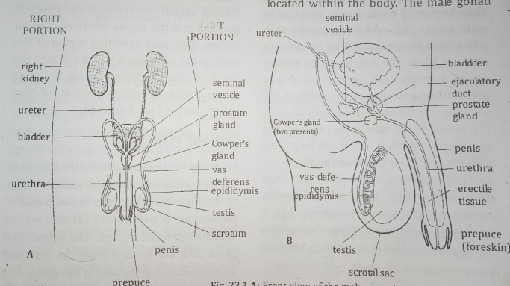

1. Front view of the male reproductive system or otherwise called the urinogenital system.
2. Side view of the male reproductive system.

**Penis**: The penis as an external genital is used for conveying urine and semen. The penis becomes erect as the tissue is filled with blood when the male is sexually excited. The erect penis is inserted into the vagina of the female before the ejaculation of the semen during coitus. The most sensitive region of the penis is the **glans penis**, which contains the urethral opening. When flaccid, the glans become covered with retractible foreskin called **prepuce.**

**Prostate gland**: It secretes mucus and slightly alkaline which is released during ejaculation and helps to neutralize the acidity of the vagina, making the sperm more active.

**Cowper’s gland**: This secretes mucus and an alkaline fluid into the urethra. The alkaline fluid neutralizes the acidity of any remaining urine.

**Seminal vesicle**: the vesicle secretes mucus and a watery alkaline fluid that contains nutrients, including the sugar fructose which is an energy source for the sperm.

**Histology of the testis**

The testis is composed of numerous seminiferous tubules where spermatogenesis occur. The primordial germ cells are formed from the germinal epithelium lining the wall of the tubule, and as cell division proceeds, the daughter cells move toward the lumen of the tubule**.**

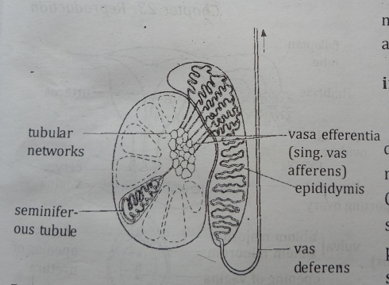

**Structure of the human testis reflecting the various tubes responsible for the movement of sperm from the seminiferous tubules to the urethra.**

The final transformation of spermatids take place in the part of the wall immediately adjacent to the lumen. At this stage, the head of the developing sperms are enveloped by serotic cells which serve as source of nourishment for the sperm. The sperm tail projects into fluid filled lumen of the tubule. Eventually, the matured spermatozoa becomes detached and are released into the lumen.

Spermatogenesis is a temperature sensitive process; if the temperature is too high, the sperm will not develop or will develop abnormally. As a result, the testes are usually held in the scrotal sac outside the abdominal cavity in the temperature between 30C to 40C. The scrotal sac of hairy mammals lack hair. High temperature can also reduce the sperm count.

**The Female Reproductive System**

**Ovaries**:- The two ovaries are the female gonads, the sites where the female gametes are formed. The gametes are known as **eggs or ova**. The almond-shaped ovaries secrete the female sex hormones **oestrogen** and **progesterone.**

**Oviducts or Fallopian tubes**:- They carry eggs from the ovaries to the uterus. The ovaries have feathering process called **fimbriae** that is very close to the ovary, particularly at ovulation. Lining the surface of the fimbrae are numerous cilia which beat rhythmically thereby generating some sort of current which draws the ovum after it has being released from the ovary. Similarly, numerous cilia lining the oviduct beat and the smooth muscle contract causing peristaltic movement which enhances the egg to descend down the oviduct to the uterus after fertilization of the egg by the sperm. They have muscular walls lined with muscular secreting cells. Fertilization occurs in the **oviducts.**

**Uterus (womb):-** The uterus is about 7.5cm long and 5cm wide and shaped like an inverted pear. The uterus enlarges in size during pregnancy because after fertilization, the zygote implants itself in the walls of the uterus and grows there until time for birth. The outer layer of the uterine wall is called **myometrium** (muscular wall of the uterus), while the inner wall is called **endometrium**. The uterus opens into the vagina through the cervix.

**Cervix:**- This is the narrow entrance to the uterus from the vagina. It is normally blocked by a plug of mucus and a ring of muscle can close it.

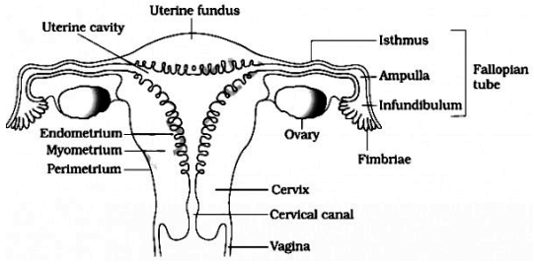

**Longitudinal view of female reproductive system**

**Vagina**:- This is a muscular tube about 8-10cm long whose walls contain elastic tissue. The lining is folded. It stretches during child birth to allow the passage of the baby and during sexual intercourse when the penis is placed in it.

**Clitoris**:- This is a small erectile structure which is equivalent to the male penis and like penis can become erect.

The external genitalia of human female or vulva include folds of skin, the **labia majora** and **labia minora**. The opening into the vagina is often reduced in size in the virgin state by a membrane –the **hymen**. Hymen, a fold of connective tissue may be present at the entrance of the vagina ( from the exterior). The hymen may rupture very easily either by sexual or non-sexual activities.

**Histology of the ovum**

Primordial germ cells are received from the germinal epithelium lining the wall of ovary which divides to form **oogonia** which migrate inwards towards the centre. Each **oogonium** becomes enveloped by a layer of follicle cells also called primary follicle. At birth, 200,000 – 400,000 primary follicles are found in each ovary, but only 200-400 complete their development while the rest degenerate into **atretic follicle** which are visible in the ovary as small cyst like bodies that never produce egg. As the oogonium matures into a primary oocyte, the follicle cells surrounding it proliferate to form a wall of many cell-thick.

As this occur, a fluid called **follicular fluid** collects between the cells. The oocyte embedded in a little projection of follicle cells projecting into the cavity. The connective tissues inside the ovary forms a protective sheath surrounding the follicle which divides into two layers: a highly vascularized **theca internal** and a less vascularized more fibrous layer called **theca external**. The whole is now reffered to as **graafian follicle**. (The graafian follicle is the stage after the first meiotic division has been completed but before ovulation. The oocyte is now a 2N haploid. The follicle is characterized by a large follicular antrum that makes up most of the follicle. The secondary oocyte, having undergone the first meiotic division is located eccentrically. It is surrounded by the **zona pellucida** and a layer of several cells known as the **corona radiata**.

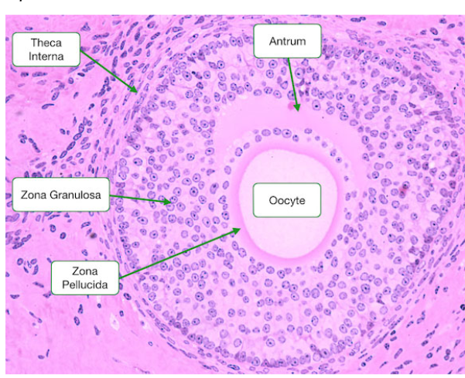

**Structure of the graafian follicle**

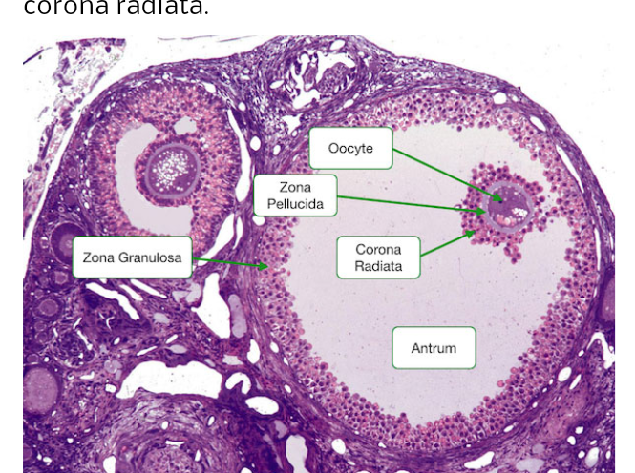

**Structure of the matured graafian follicle.**

Simultaneously, the follicle moves slowly backward toward the surface of the ovary and increasing in size as well which eventually causes a distinct bulge (bud) on the surface of the ovary.

When the time is ripe, this bud ruptures, releasing the oocyte from its attachment to the wall of the follicle (the oocyte is now a 2N haploid) and is ejected from the ovary into the ampulla of the oviduct (this is where fertilization occur). The process is called **ovulation.** The ovum released from the graafian follicle into the oviduct consist of three structures: **oocyte, zona pellucida** and **corona radiata.** After the release of the ovum, the remaining cells of the **granulosa** and **theca interna** form **corpus luteum**.

Gametogenesis in humans (Spermatogenesis and oogenesis

In animals such as humans, meiosis occurs as gametes are formed inside the testes and ovaries. The formation of male gametes is known as **spermatogenesis** and the formation of female gametes is known as **oogenesis**.

Spermatogenesis:- Sperm production take place inside tubules in the testes. The diploid cells divide by mitosis to produce numerous diploid **spermatogonia**, which grow to form **diploid primary spermatocytes.**

Spermatogenesis (formation of sperm)

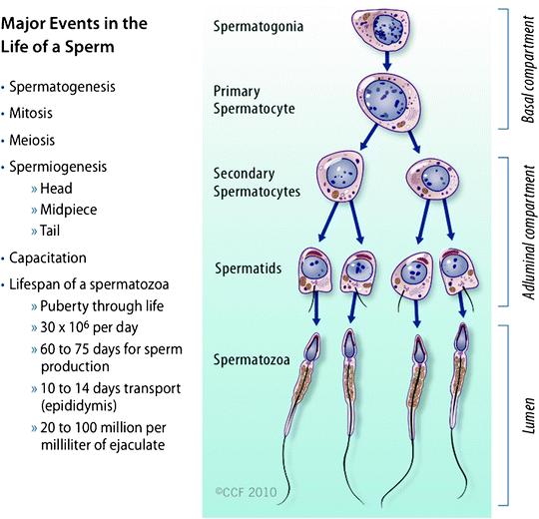

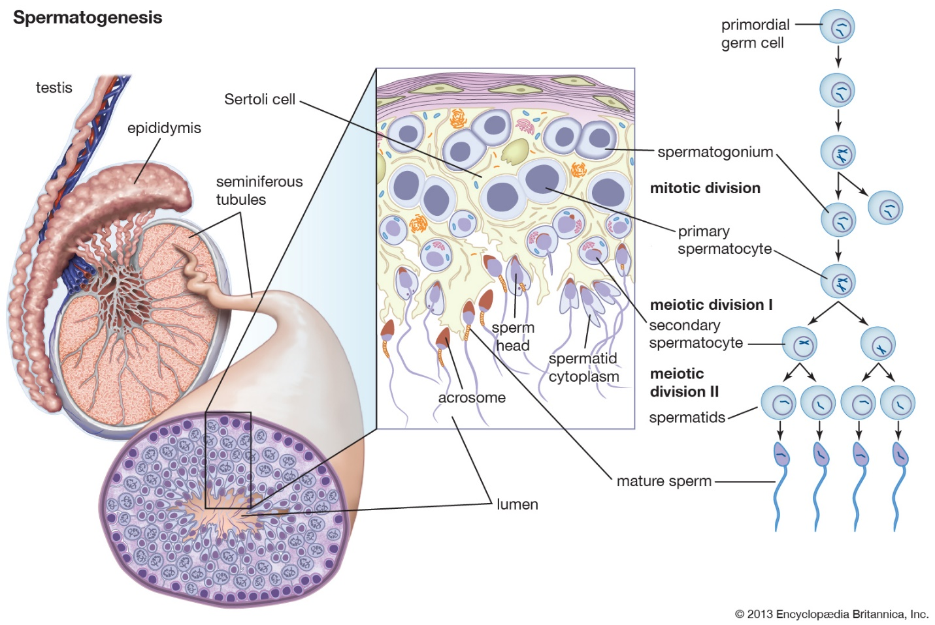

The first division of meiosis then takes place forming two **secondary spermatocytes.** The second division of meiosis then produce **haploid spermatids**, which mature into **spermatozoa.** **NOTE**: Spermatid is an unspecialized cell. The numerous spermatozoa are formed from a single primordial germ cell.

**Oogenesis** follows a similar pattern but takes longer time. It takes place inside the ovaries, where diploid cells divide by mitosis to produce many oogonia. The **oogonia** begin to divide by meiosis, but stop when they reach prophase 1.

At this stage, they are called **primary oocyte**, and still diploid. All of this happens before a baby girl is born, and at birth she has around 400,000 primary oocytes in her ovaries. When she reaches puberty, some of the primary oocytes undergo further division by meiosis. They proceed from prophase 1 to the end of the first meiotic division, forming two haploid cells.

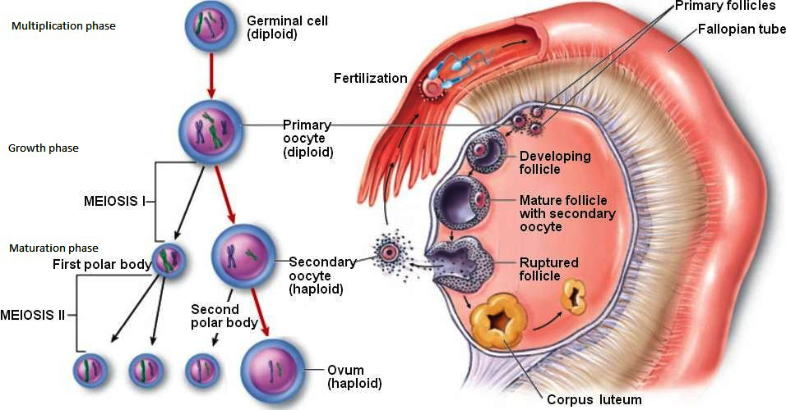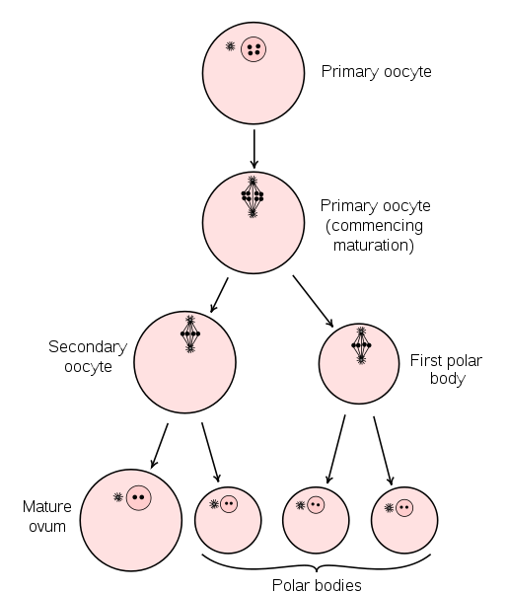

**Diagrammatically representation of oogenesis.**

Each month, one **secondary oocyte** is released into the oviduct from one of the ovaries. If it is fertilized, it continues its division by meiosis and can now be called an **ovum**. The chromosomes of the **spermatozoon** and the ovum join together to form a single diploid nucleus, and the cells that is made by this process is called a **zygote**. The zygote can now divide repeatedly by mitosis to form first an embryo and then a **foetus.**

**Sperm cell**

The spermatozoon can be divided into five basic regions namely: the head, neck, middle piece and tail and the end piece. Inside the head is the genetic material within a large **nucleus.**

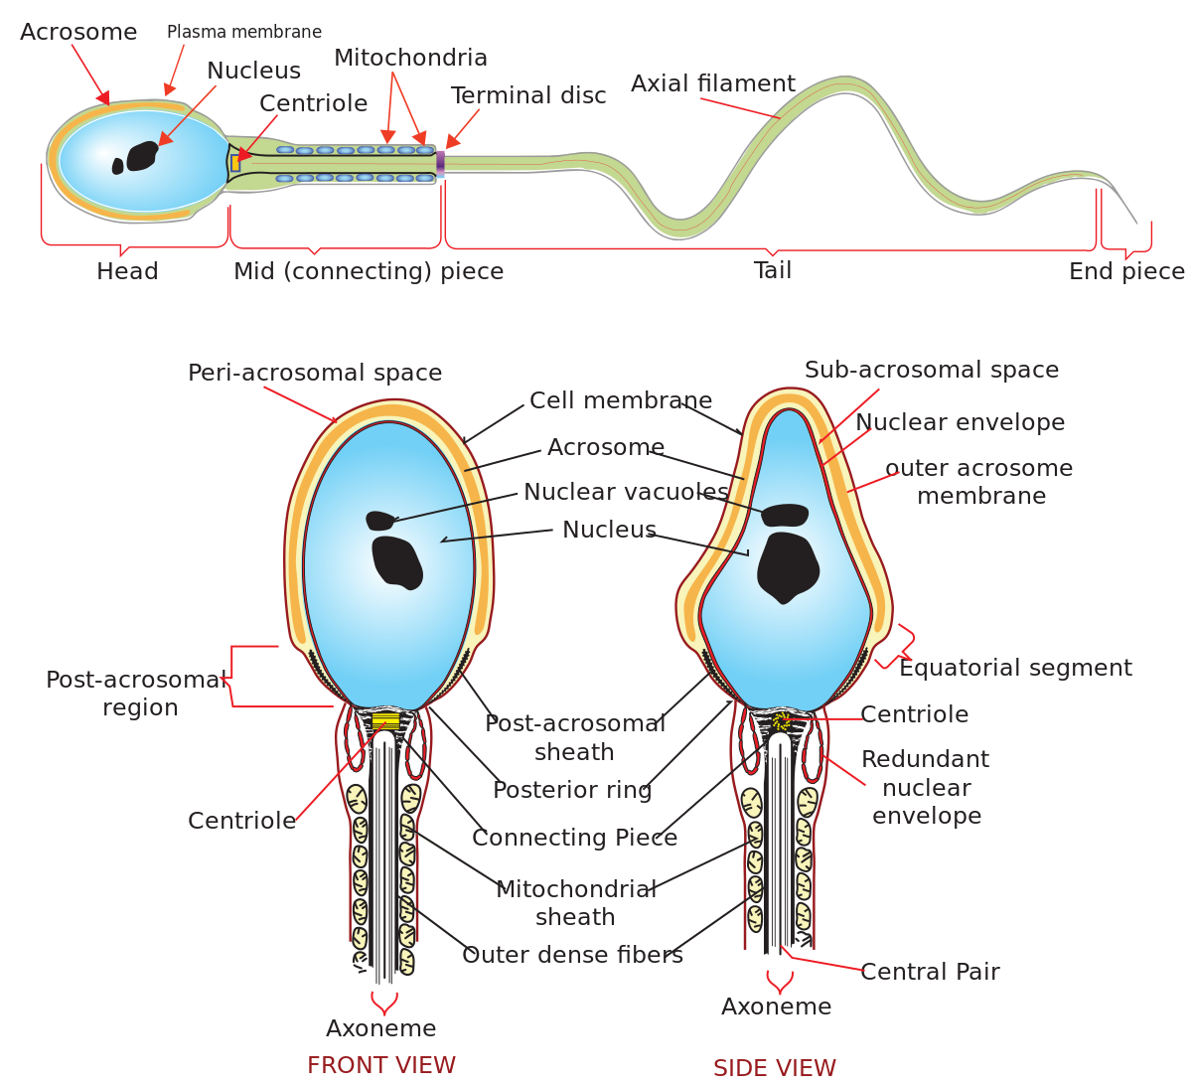

Immediately above the nucleus is a thin cap acrosome which plays an important role in fertilization. The rest of the body performs majorly the function of propulsion. In the middle piece, the axial core is densely packaged with mitochondrion-this is concerned with releasing energy that set the spermatozoon on motion.

**The Egg**

The egg is much larger than the spermatozoon with the diameter of 0.1mm and with less complicated structure. The egg cell has a haploid nucleus surrounded by dense cytoplasm. Cortical granules and yolk droplets are inclusions found in the egg. The yolk is a mixture of proteins and fats and it is concentrated towards the lower part of the egg away from the nucleus.

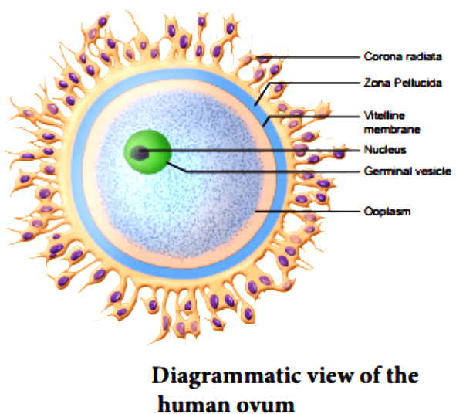

The non-yolky part contains the nucleus and the cytoplasm and the yolkier end called the **vegetal yolk**. The function of the yolk is to provide nourishment for the embryo in its early stage of development. Eggs however, differ in the quantity of yolk they contain. For instance, in bird’s egg, there is considerably vast quantity of yolk while in toads; the yolk are much smaller in quantity. In some cases, the nutritive tissue surrounds the embryo e.g the endosperm tissue in flowering plants.

**TUTORIAL QUESTIONS**

1. Define the term reproduction.
2. Explain different types of vegetative propagation with examples.
3. Briefly explain the followings:- i. Cloning ii. Agamospermy iii. Budding, fragmentation and conjugation in lower organisms.
4. Describe the structure of the human male and female reproductive systems.
5. Identify the parts of the gametes (male and female).
6. Explain in details the process of gametogenesis.
7. Summarise few forms of abnormalities of sexual reproduction in plants and unicellular organisms.